SIMATS ENGINEERING (SAVEETHA SCHOOL OF ENGINEERING)
Department of Artificial Intelligence and Data Science
ASSESSMENT TOOL 1 – Data Interpretation

Course Code: | DSA03 | Course Title: | Natural Language Processing
CO Assessed: | CO4 – Precision | Assessment: | Assessment Tool 1 – Data Interpretation
Weightage: | 35% of CIA
CO5 Statement: | Formulate context-free grammars, feature structures, probabilistic parsing techniques and to construct parsing frameworks. (BL-4)
Student Name: | G. Devi Sri | Reg. No.: | 192472025
Section / Batch: | CSE-AI | Date: | 17/08/2026

Code of Conduct
I G. Devi Sri / 192472025 (Name / Reg No) certify that this submission is my original work and that I have adhered to the guidelines specified for this assessment. I understand that any violation of academic integrity rules will result in disciplinary action.
Signature of the Student: G. Devi Sri

Instructions
- Read each data set, table, semantic representation, or scenario carefully before answering.
- Analyze the given information and provide logical, evidence-based interpretations.
- Show all intermediate reasoning, semantic analysis steps, predicate representations, or calculations wherever applicable.
- Answers should be concise, structured, and technically accurate.
- Support your conclusions using the data provided in the question.
- Draw diagrams, semantic networks, parse trees, or logical representations wherever relevant.
- Avoid copying definitions alone; focus on analyzing the given scenario and interpreting the data.
- Duration: 30 minutes.

Section / Topic | Focus | Question No.
Representing Meaning & Meaning Structure of Language | Analyze semantic representations, identify action–entity relationships, detect interpretation errors, and evaluate meaning representation in chatbot systems. | Q1
First-Order Predicate Calculus & Representing Linguistically Relevant Concepts | Construct predicate representations, apply logical inference rules, derive conclusions, and evaluate reasoning in smart manufacturing environments. | Q2
Lexemes and Their Senses & Word Sense Disambiguation | Analyze contextual clues, determine correct word senses, evaluate ambiguity resolution, and improve semantic understanding in search systems. | Q3
Syntax-Driven Semantic Analysis | Analyze syntactic structures, assign semantic roles, evaluate parsing accuracy, and improve semantic interpretation in healthcare NLP applications. | Q4

Annexure A – Data Interpretation

1. Frame Semantics in Banking Customer-Service Systems
A digital banking platform uses semantic frames to understand customer requests. The NLP system identifies the action, agent, object, and destination involved in each request.
Customer Query | Generated Semantic Frame
"Transfer ₹20,000 from my savings account to my son's account." | TRANSFER(SourceAccount, Amount, DestinationAccount, Customer)
"Block my debit card immediately." | BLOCK(DebitCard, Customer)
"Send my transaction statement to my email." | SEND(TransactionStatement, Email, Customer)
"Increase my daily withdrawal limit." | MODIFY(WithdrawalLimit, Customer)
Additional transaction logs show:
Query ID | Actual User Intent | System Interpretation
B1 | Transfer money to another account | Transfer money
B2 | Block debit card | Block debit card
B3 | Receive transaction statement by email | Send statement to email
B4 | Increase withdrawal limit | Decrease withdrawal limit
Tasks:
- Analyze the semantic frame of each banking request and identify the relationship between the action and its participants.
- Identify the query in which the semantic interpretation is incorrect and explain why.
- Analyze how incorrect identification of semantic roles can lead to an incorrect banking operation.
- Recommend a frame-based semantic analysis approach to improve the reliability of banking conversational systems.

2. First-Order Predicate Calculus for Smart Agriculture
A smart agricultural system monitors crop fields using sensors and logical rules.
Field Data:
Field | Soil Condition | Irrigation Status | Crop
F1 | Dry | Available | Rice
F2 | Wet | Available | Wheat
F3 | Dry | Unavailable | Maize
F4 | Wet | Unavailable | Rice
The system uses the following predicate rules:
- Dry(x) ∧ IrrigationAvailable(x) → NeedsWater(x)
- NeedsWater(x) → Irrigate(x)
- Wet(x) → ¬NeedsWater(x)
- IrrigationUnavailable(x) → ¬Irrigate(x)
- Rice(x) ∧ NeedsWater(x) → PriorityIrrigation(x)
Tasks:
- Represent the field observations using First-Order Predicate Calculus.
- Using the given rules, determine which fields require irrigation.
- Determine whether F1 and F3 should be treated differently by the automated irrigation controller.
- Analyze whether predicate logic alone is sufficient for agricultural decision support when sensor information is incomplete or uncertain.

3. Word Sense Disambiguation in a Travel Recommendation System
A travel platform receives search queries containing ambiguous words. The recommendation engine uses surrounding words and user interactions to determine the intended meaning.
Search Query | Possible Sense 1 | Possible Sense 2
"Amazon tour" | Amazon rainforest | Amazon company
"Safari booking" | Wildlife tour | Web browser
"Java vacation" | Java island | Java programming language
"Cruise package" | Ship journey | Cruise software/project
The system records the following user interactions:
Query | User Interaction
Amazon tour | Viewed rainforest trekking packages
Safari booking | Selected wildlife resort packages
Java vacation | Viewed hotels in Bali and Java
Cruise package | Viewed Mediterranean ship packages
However, another user searches: "Safari download for Windows" and clicks a browser download page.
Tasks:
- Determine the intended sense of the ambiguous terms using the available context.
- Identify the lexical and contextual cues that distinguish the possible senses.
- Analyze why the same word may require different interpretations for different users.
- Design an industrial-scale WSD strategy using query context, user history, embeddings, and click behaviour to improve travel recommendations.

4. Syntax-Driven Semantic Analysis in Legal Document Processing
A legal NLP system analyzes sentences from contracts and assigns semantic roles based on their syntactic structures.
The system produces the following analyses:
Legal Sentence | Parse Structure | Generated Semantic Interpretation
"The supplier delivered the equipment to the buyer." | Subject–Verb–Object | Supplier = Agent, Equipment = Object, Buyer = Recipient
"The buyer received the equipment from the supplier." | Subject–Verb–Object | Buyer = Agent, Equipment = Object, Supplier = Recipient
"The company terminated the contract after the violation." | Subject–Verb–Object | Company = Agent, Contract = Object
"The contract was terminated by the company." | Passive Construction | Contract = Agent, Company = Object
Tasks:
- Analyze how syntactic structure, including active and passive constructions, influences semantic-role assignment.
- Identify the incorrect semantic-role assignments in the given interpretations.
- Explain how confusing grammatical subject with semantic agent can affect automated legal information extraction.
- Recommend a syntax-driven semantic analysis architecture that can correctly handle active voice, passive voice, prepositional phrases, and long-distance dependencies in legal documents.

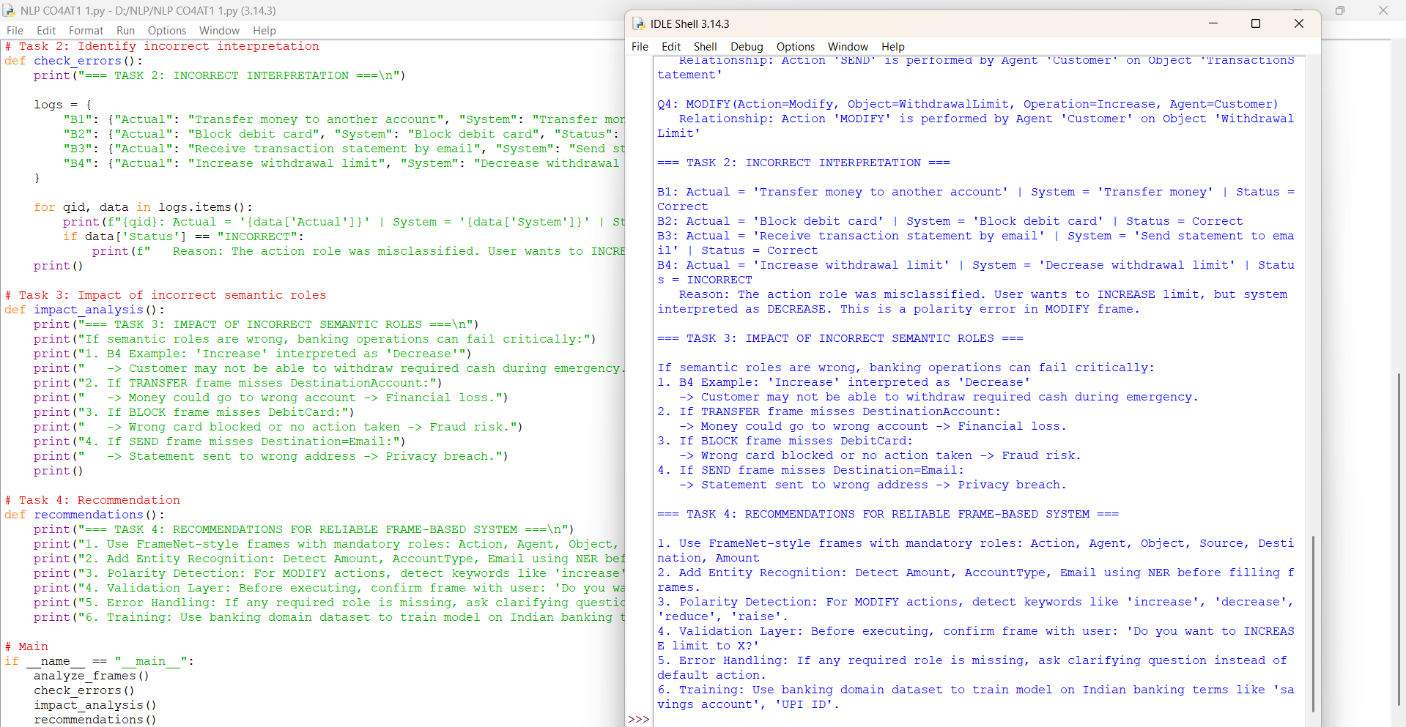
2.
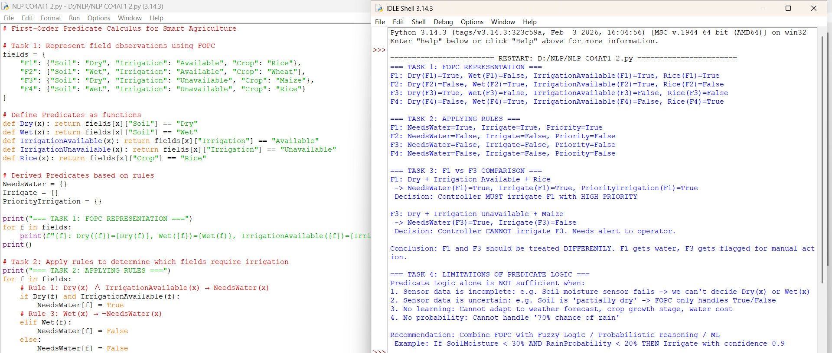

3.
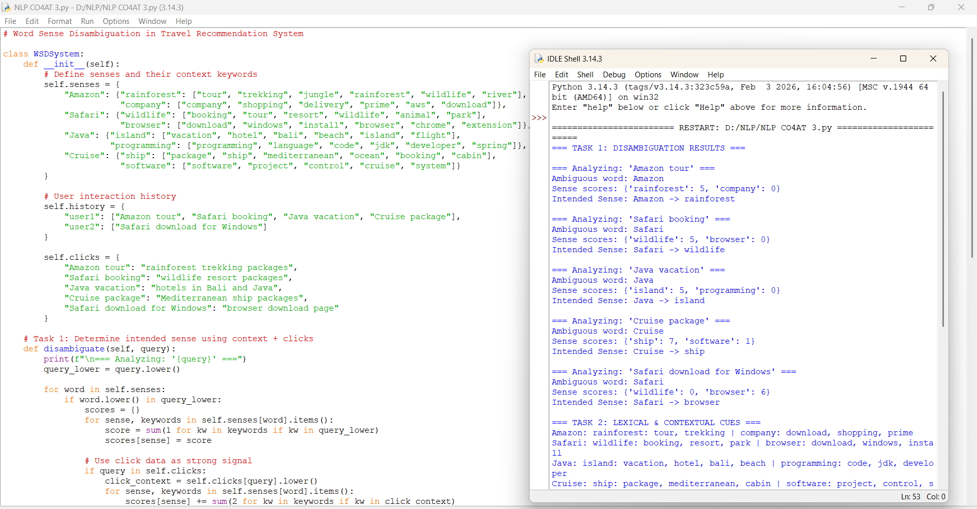
4.
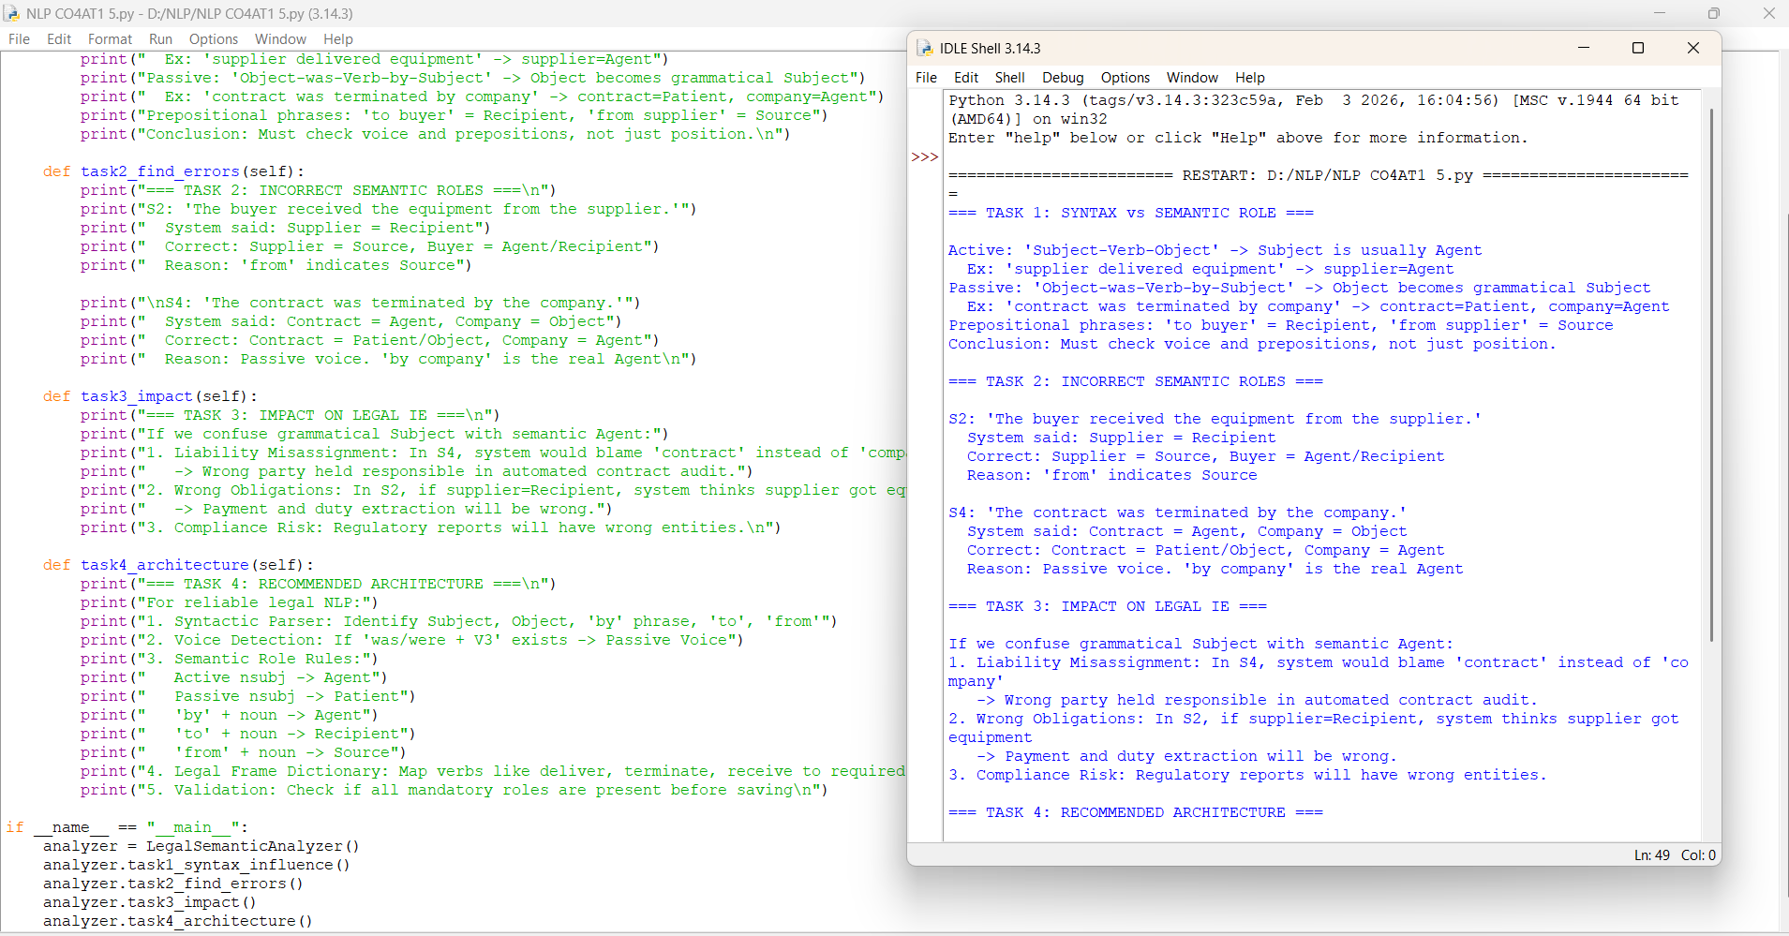

Rubrics for Calculation

Criteria | Weightage | Level 4 (Exemplary) | Level 3 (Proficient) | Level 2 (Developing) | Level 1 (Beginning)
Understanding of Data | 25% | Accurately interprets all data patterns, trends, and relationships | Interprets data correctly with minor gaps | Partial understanding; misses key trends | Misinterprets or fails to understand data
Analysis | 25% | Provides deep analysis with strong logical reasoning and justification | Provides reasonable analysis with some justification | Basic analysis with weak reasoning | No meaningful analysis provided
Application of Concepts | 20% | Effectively applies relevant concepts/tools to interpret data accurately | Applies concepts with minor errors | Limited application; requires guidance | Unable to apply concepts to data
Conclusion | 20% | Draws clear, meaningful conclusions with strong insights and implications | Provides valid conclusions with moderate insights | Conclusions are vague or weak | No clear or valid conclusions
Clarity | 10% | Presents interpretation clearly using proper structure, visuals, and terminology | Generally clear with minor issues | Lacks clarity or proper structure | Poor presentation and difficult to understand

Q. No. / Criteria Level | Understanding of Data | Analysis | Application of Concepts | Conclusion | Clarity | Sub. Total | Total %
1 | 5 | 5 | 5 | 5 | 5 | 25 | 86
2 | 5 | 4 | 4 | 4 | 4 | 21
3 | 4 | 4 | 4 | 4 | 4 | 20
4 | 4 | 4 | 4 | 4 | 4 | 20

Faculty In-charge | Course Coordinator | Program Director
Signature: _______________ | Signature: _______________ | Signature: _______________
Date: ___________________ | Date: ___________________ | Date: ___________________

